Task 1:

0 NF:



1 NF:

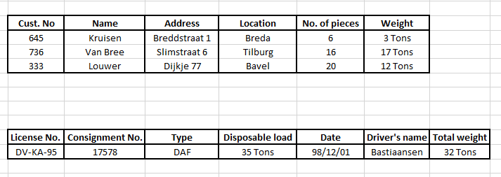

2 NF:

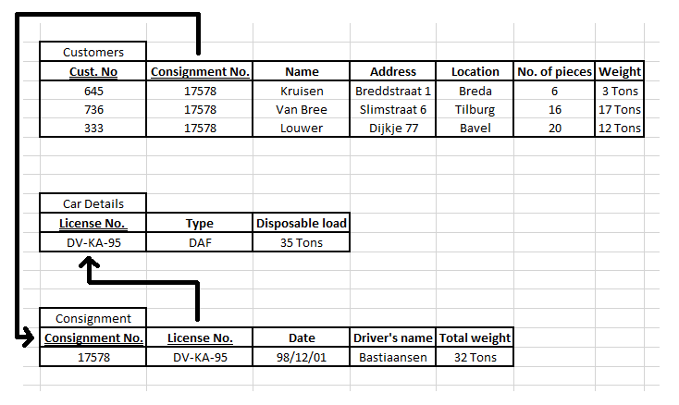

3 NF:

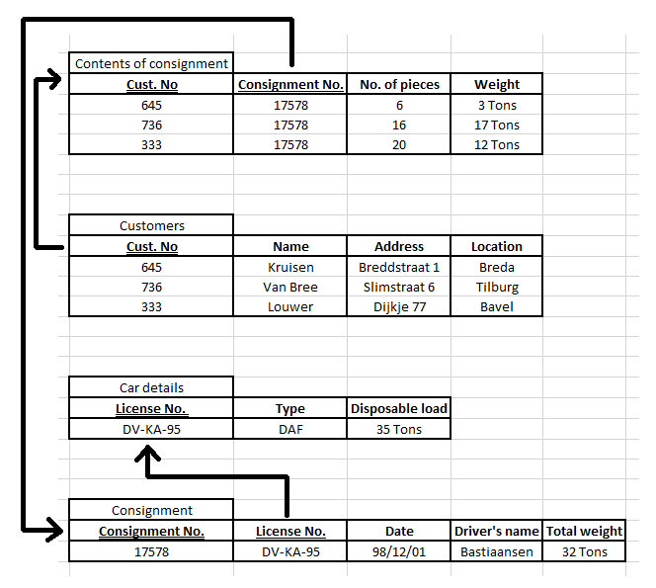

Task 2:

1.

- Phone -> Room, Building, Department

- Lecturer’s Code -> Name

2.

Phone would be the primary key, because it is a phone list.

1 NF:

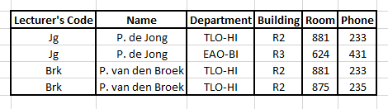

2 NF:

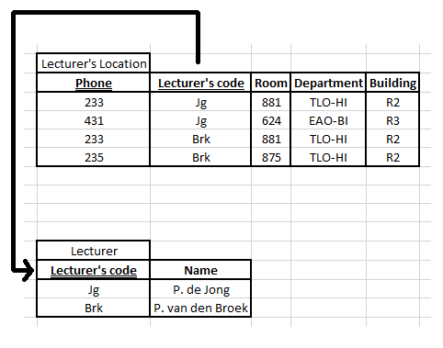

3 NF:

